وزارة التربية والتعليم
الاختبار الموحد في اللغة الإنجليزية
الصف الخامس الفصل الثاني 2014
Part one: reading
Ben has a nice blog on the internet. He writes his ideas everyday and he puts some photos in the blog. Ben’s favourite hobby is taking photos. He took a photo of the sea and the moon last weekend. The sea looked like a mirror. 7
Last summer Ben was at the Manchester United football game. It was a very exciting game. Manchester United won. He broke his leg at the football game. He couldn’t move. His dad took him to the hospital. It was very busy. Ben wrote about his leg on his blog. His friends in England read about his leg.
Ben also writes about his family. Yesterday they went to a restaurant. It was a nice place. They ate rice and meat. They went to the park after the restaurant. They had a great time.
- Read. Put (√) or (X):
  - Ben does not enjoy taking phots. ( )
  - The hospital was very busy. ( )
- Read and circle the correct words.
  - Ben’s father / friendstook him to the hospital.
  - Ben wrote an email / a blog.
- Read and complete the sentences.
  - Manchester Unitedwon the ………………………………………
  - Ben’s family ate rice and meat at the .............................................
  - The .............................went to the ........................... after the restaurant.
- Read. Write answers to the questions.
  - How did the sea look like? ………..……………………………………
  - Why couldn’t Ben move? ……………………….………………………
- Read and match



a. went to the hospital b. had a great time c. had an exciting game
Complete the sentences with the correct words.
click palace vegetables tomorrow planets
- Omar is going to tell me about his holiday ....................................
- The princess lived in a .........................................
- Scientist will travel to ............................ by spaceship.
- Potatoes, onions and carrots are ....................................
- You ...................................the mouse to play a new game.

Part two: writing
- Write the correct words.
  - When you go to Sabastiya, you can see lots of old …………………. (ned)
  - Press the ………………….. to choose the programme. ( gyrna)
  - All the family went to the ………………………… (tlofa)
  - My dad took me to the ……………………………… (utnr)

- Write correct sentences. Use (capitals, full stops)
  - thefamilycannot move in a car
……………………………………………………………………………………..
  - did omar get out of the cold water
……………………………………………………………………………………

- Write correct sentences.
  - took / Rami/ . /of / photos / a lot
………………………………………………………………………………………
  - wedding / where / ? / was / the
………………………………………………………………………………………

- Complete the sentences. { me - him – her – them }
  - Amal is busy. Let’s help .........................................
  - This is my family’s photo. This is ..........................and that’s dad.
  - Omar is on the telephone. Please talk to …………………………………
  - Look at the children. Let’s take a photo of .......................................

- Complete the table.
 | tell | told
1 | ………… | chose
2 | press | ……….
3 | ……….. | went
4 | move | ………..

- Read and circle the correct words.
  - The film was / weregood.
  - I played / am playing basketball now.
  - My brothers are going to leave / leftNablus tomorrow.
  - I don’t want any / some grapes.
  - The girlsdidn’twrite / wrotethe homework.

7. Look and complete the sentences.
Sure, here you
………........……………………… please?

8. Complete the sentences.
What did the children do yesterday?
  - Rawan………………....... a picture. (paints)
  - Kamal ............................ the pencil. (break)
What are the children doing now?
- Sami ............................................a song. (sing)
- The children ….....…………………. to a story. (listen)

9. Write four sentences about what those people are going to do tomorrow.
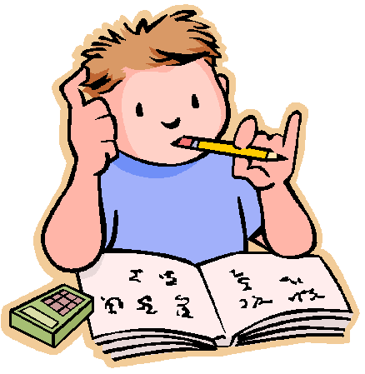


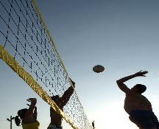

The boys Nada Kamal and SamerSawsan
watch / play / homework / TV / swim / / do

- The boys ……………………………………………………………………………..
- Nada ……………………………………………………………………………………..
- Kamal and Samer………………………………………………………………………
- Sawsan………………………………………………………………………………….

10. Copy this sentence.
I am going to travel to Hebron next holiday
………………………………………………………………………………..

Listening:
1. Listen and put (√) or (X):
- The farmer bought a small goat at the market. ( )
- A wolf heard the goat and wanted it. ( )
- The farmer hid behind a tree. ( )
- The farmer wanted two shoes. ( )
- In the end, the farmer took the shoes and the wolf took the goat. ( )
- The farmer was happy. ( )
2. Listen and number the pictures.
.................. ...................... ....................
.................. .................. .................
3. Listen and complete.
next | tour | tomorrow
Ben’sfamily are going to have a holiday.They are going on a ….........……… of Palestine. They are going ........................... October. Ben is going to tell Omar .....................................
4. Listen and circle the correct words.
- They are going to visit Hisham's Palace after / before lunch.
- They are going to float / swim in the Dead Sea.
- The family will see the church of the Nativity in Bethlehem / Jerusalem.
- They are going to leave Gaza in the afternoon / evening.
5. Listen and put (√)
Things to do | Jerusalem | Ein Kenya | Sabastiya | Jenin | Gaza
swim in the sea
see olive farms
visit the old market
see animals and birds
see old ruins

مزيد من اختبارات اللغة الانجليزية للصف الخامس من هنا
https://www.wepal.net/library/?app=content.list&level=5&semester=2&subject=5&type=2

